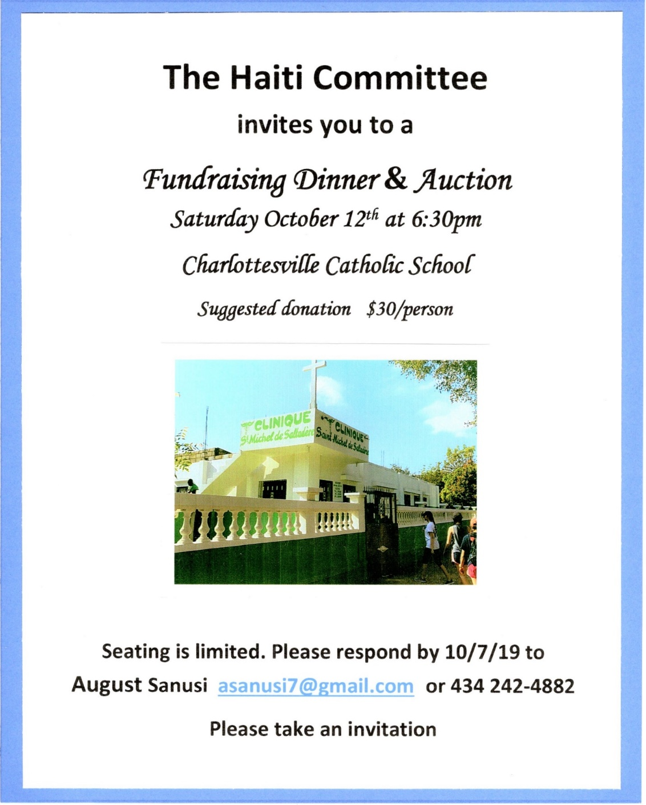
Bidding is open now- go to http://bidpal.net/haitiauction
Information via Facebook fb.me/saltadere that links to
https://info941709.wixsite.com/haiti-committee-site

